Task 7

1. Chat GPT

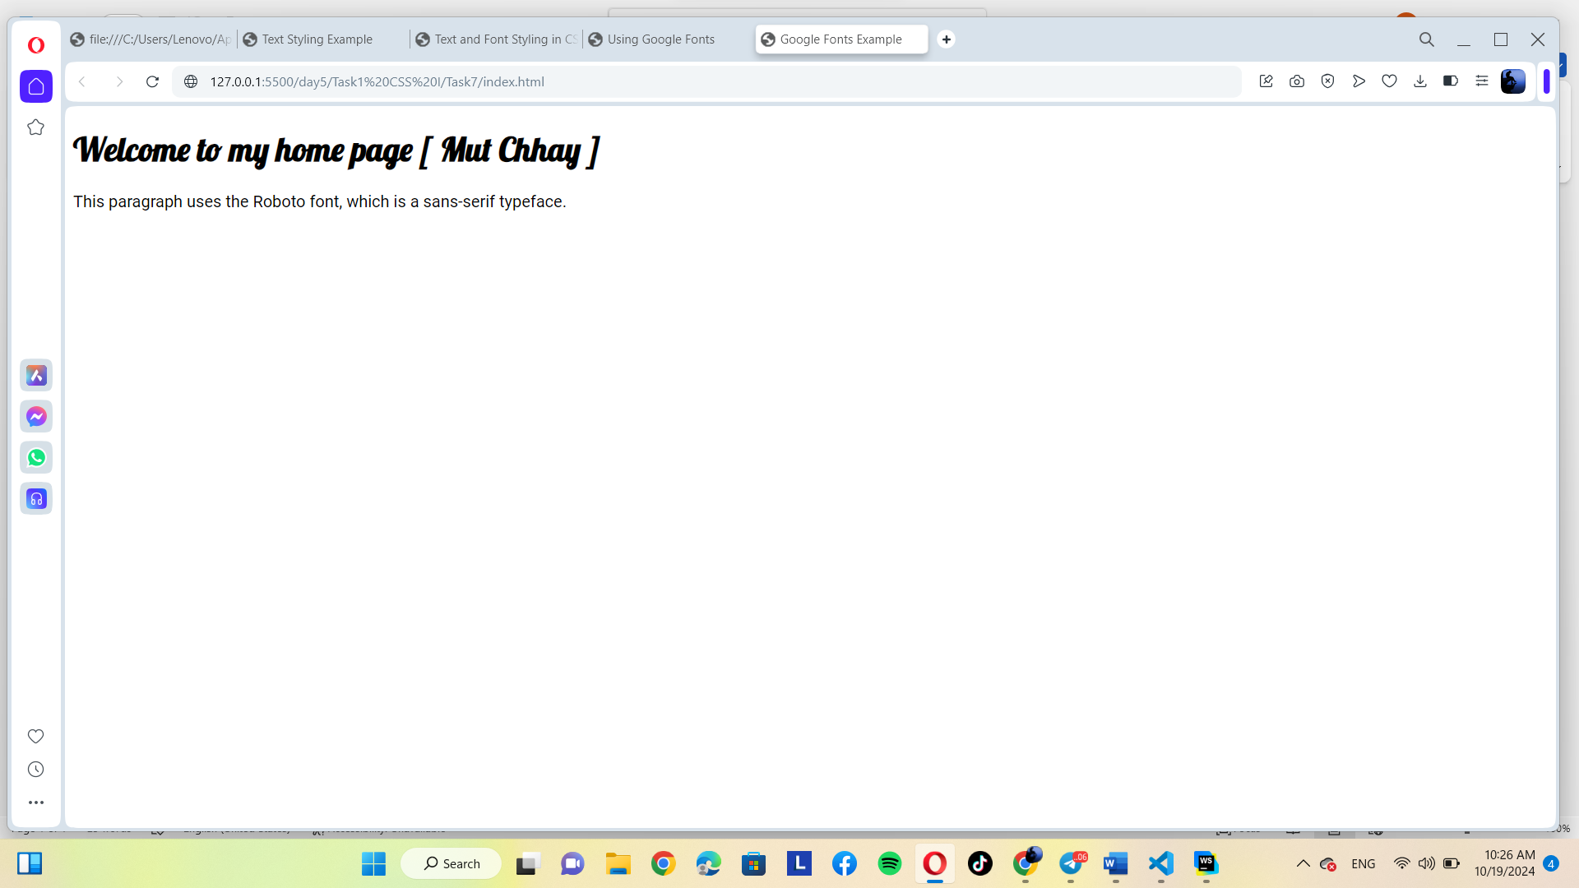

2. Gemini

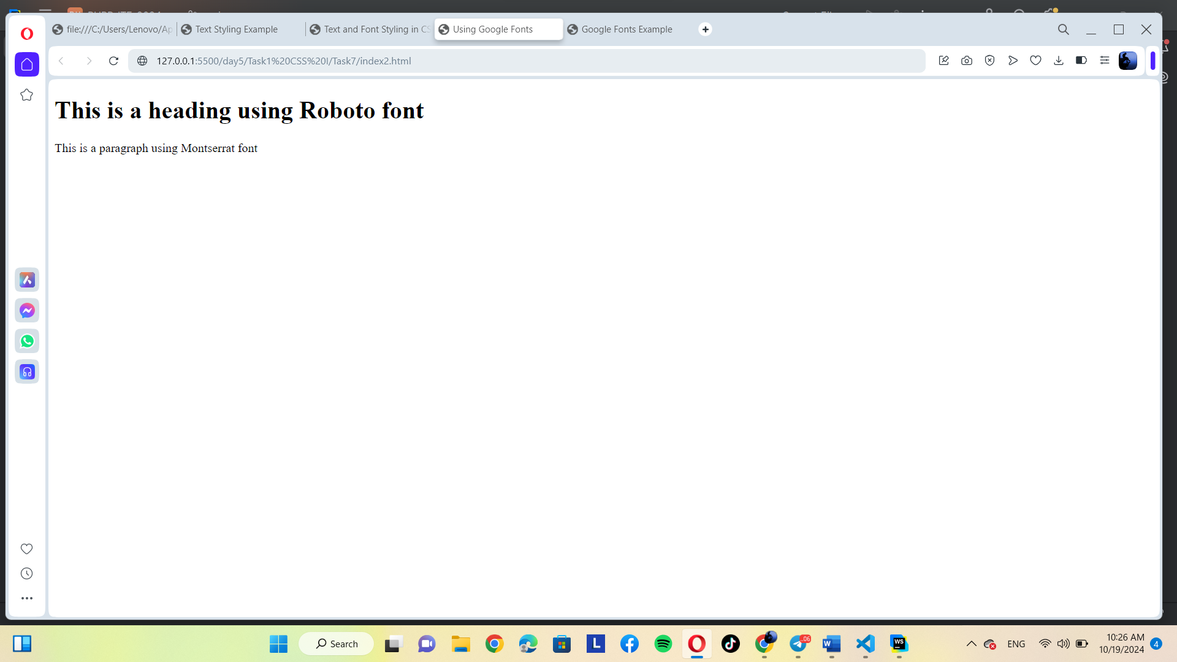

Both had follow the prompt and the same explaining